**Latest advancement**

**in the Field of AI:**

**Nov.03.2023**

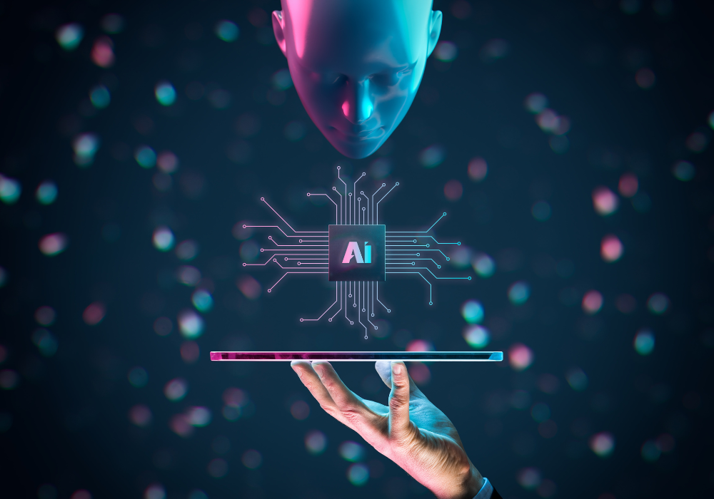

“There’s a real need for symbolic reasoning and alternative routes to intelligence that are going to be necessary to make more robust AI tools.”

— Kevin Kelly, Wired co-founder and author of the best-selling book The Inevitable

* Artificial intelligence (AI) has crept into every aspect of our life over the last few decades. And there a chance that AI is going to beat any new technology in these coming years. It’s an advancement of every filed who start any things like coding or any startup business or any E-commerce platform. The Recent market has understood with the concept of AI and working together. Due to advancement of computer platform and large dataset, the field of AI has experienced a tremendous growth.
* **The Growth Of AI:**

You think that many of us have spent a few hours tinkering with DALL-E 2, an AI text-to-image generator capable of producing detailed graphics from the most odd requests. But…how many of us realize that what technology goes behind those images? The app doesn’t show any external images but rather then they used a complicated process called diffusion to refine a series of pixels until the visual rendering matches the text description.

Consider this: whether you are a digital artist, illustrator, or graphic designer, how much would your profession alter if you could make a realistic-looking image in seconds using an app? These technologies are linked to real-world applications with substantial consequences.

* **AI-Powered protein folding:**

AlphaFold, a deep learning model from Google AI, has been able to predict the 3D structure of nearly all known proteins. This is a significant biological discovery that might lead to new discoveries in medication design and vaccine development.

* **AI in Healthcare**

AI in the healthcare business is not for everyone. Much progress is being made in the research and development of treatments, including the ability to identify a condition using a CT lung scan and modelling the protein structure of the SARS-COV-2 virus that causes COVID19. The government and other organizations have investigated AI to track epidemics and anticipate where they may occur in the future.

* **What does the future hold for Artificial Intelligence advancements?**

AI's future holds enormous promise for dramatic improvements throughout businesses and society. AI is projected to grow progressively more intelligent and competent as research and technology advancements continue. We may expect increased automation, personalized experiences, and better decision-making. AI will work alongside humans, boosting their talents and opening up new avenues for creativity.

Ethical concerns and ethical AI practices will become more prominent, assuring justice, transparency, and accountability. The effect of AI will extend to the social good, solving societal issues and generating constructive change. As AI evolves, multidisciplinary integration and trust-building measures will influence its direction, and it will contribute to societal good by tackling crucial concerns and increasing quality of life.

* **Final Thoughts:**

AI is the single most significant paradigm change. and it's advancing at a significantly quicker rate than previous transitions. Cloud computing, mobile computing, and the internet have all transformed the game, but none has progressed as quickly as AI. As artificial intelligence advances, it will eventually eclipse the influence of previous technological enablers, even as it increases the applicability and impact of existing technologies.